**// Subroutine : UpdateButtonClick_OPTIONS_TIEFIX()**

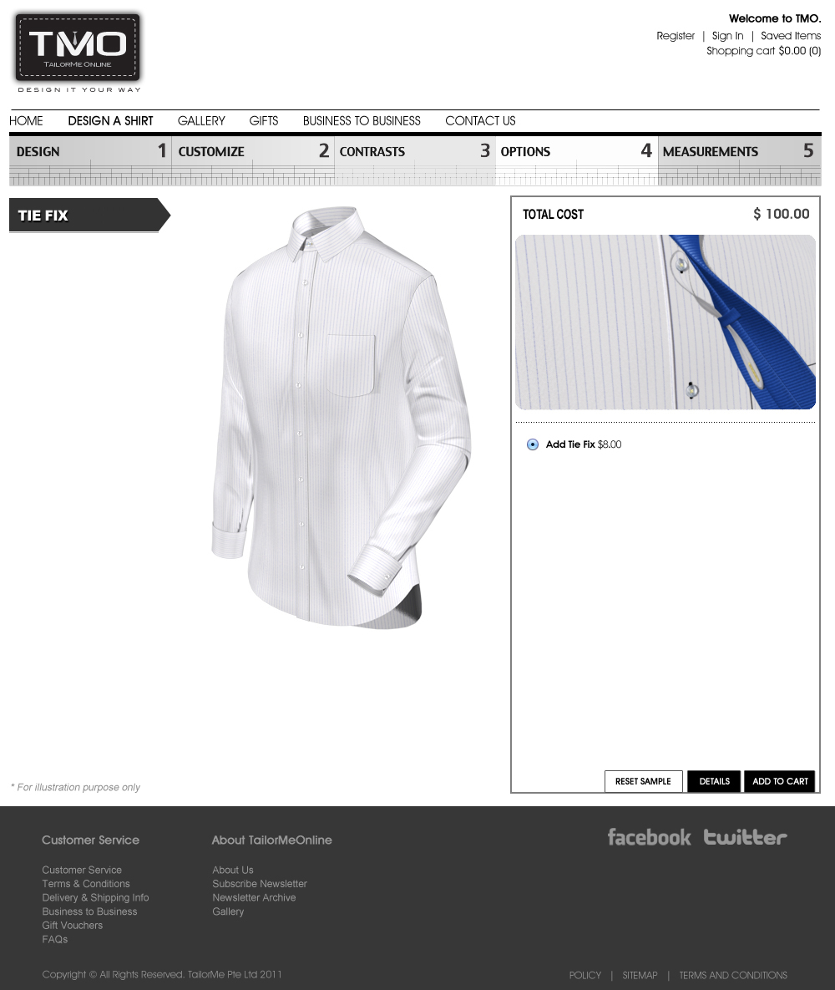

To display the Tie Fix window when entering this page, call subroutine : DisplayTieFix();

There is no visual change upon clicking on the toggle button (Add Tie Fix), hence no need to update the display.

**// End of Subroutine : UpdateButtonClick_OPTIONS_TIEFIX()**